**Workshop Instructions**

**Materials for this workshop:** [**go.ncsu.edu/rworkshop**](http://go.ncsu.edu/rworkshop)

**Setup: Getting R in Your Machine**

**Downloading and Installing R**

**1. Go to -** [**https://www.r-project.org/**](https://www.r-project.org/)

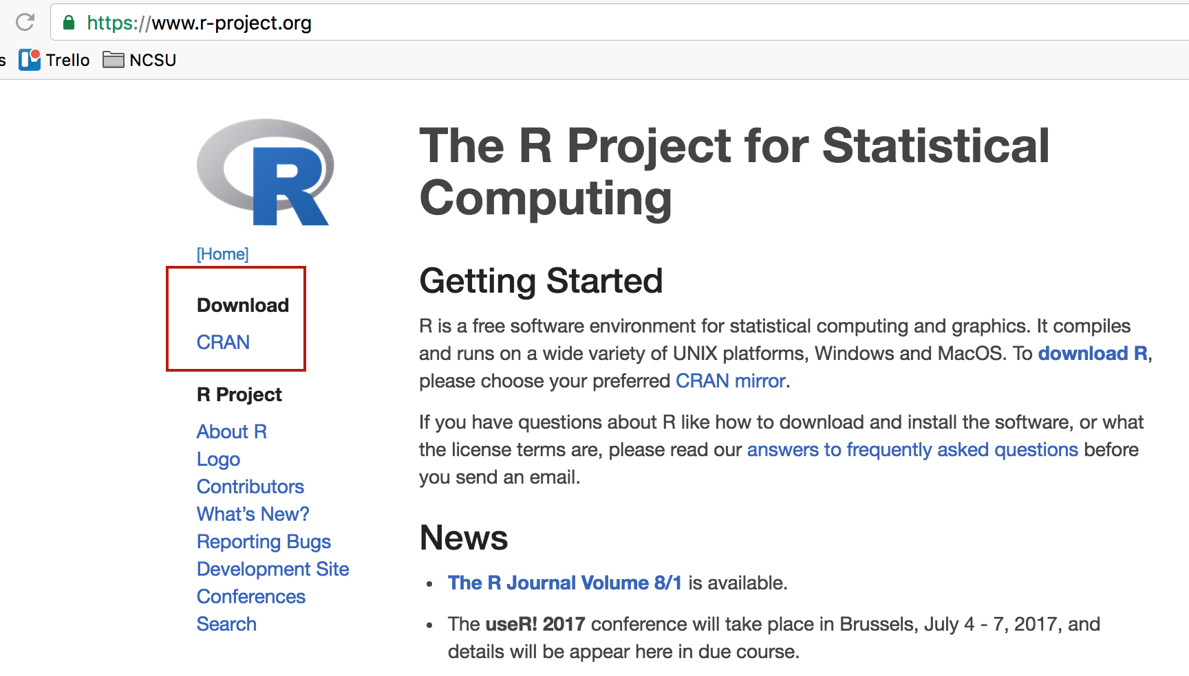

**2. Select one of the CRAN mirrors listed under USA -- Duke University is closest**

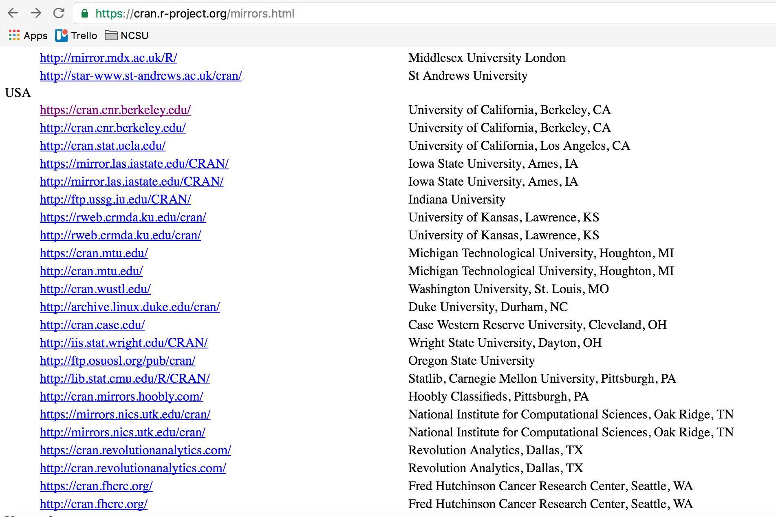

**3. Download the R Version for your operating system (Windows, Mac, or Linux)**

**4. Download R Studio** - <https://www.rstudio.com/products/rstudio/download3/>

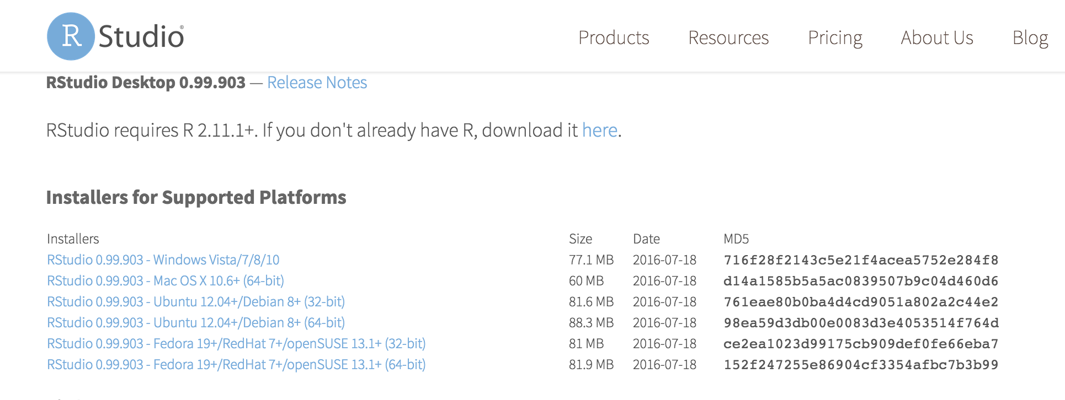

**Understanding the structure of R Studio**

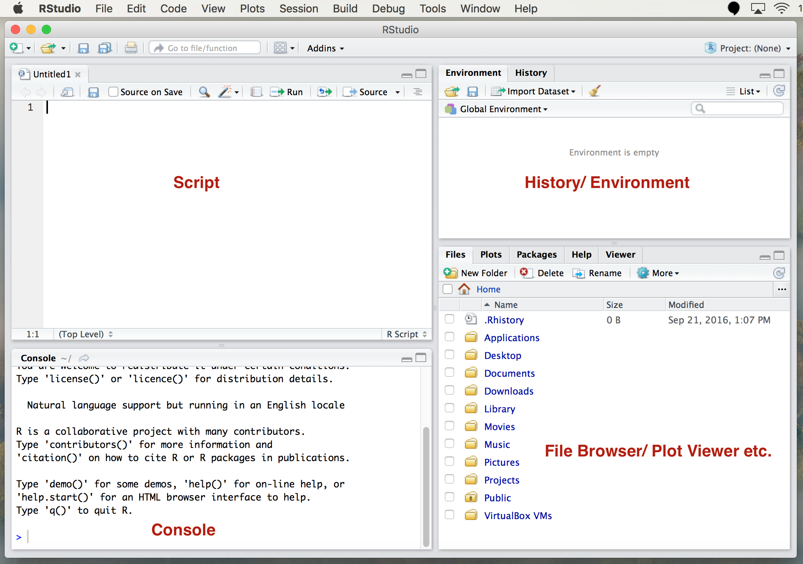

**Activity 1**

**1. Understanding prompts:**

* In console a new line starts with >. This means it is waiting for us to communicate

**Type 2+3 in the Console and hit Enter:**

> 2+3

[1] 5

* If we give it an incomplete command then it returns +. Press esc button to return to a new line.

**Type 2+3+ in the Console and hit Enter:**

> 2+3+

+

**Now type 7 and hit Enter:**

> 2+3+

+ 7

[1] 12

**Hit the up arrow until you see 2+3+ pop up (the up arrow lets you access previous commands). Hit enter.**

**Now press ESC. This starts a new prompt.**

> 2+3+

+

>

**2. Set working directory (Get default directory/Grab path)**

In the console type **getwd()**.

This will return the current working directory, listed as a file path.

> getwd()

[1] "/Users/ablaine"

**Let’s create a new folder and set that as our working directory.**

**in In the lower-right corner File Browser menu, double Click on the Desktop Folder**

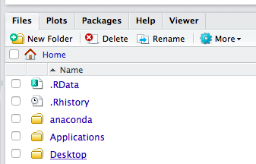

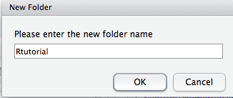

**Click on “New Folder” to create a new folder on your computer’s Desktop**

**Name the folder “Rtutorial”. Click OK**

**Double click on Rtutorial folder title to go inside of the folder**

**Click More, then Set As Working Directory**

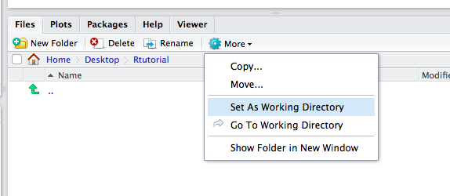

**When you do that, your Console should have this output:**

> setwd("~/Desktop/Rtutorial")

**\*To set your working directory manually:**

**setwd()** - To assign a new working directory copy the path of the directory where you would like to save your codes (In Mac right click on the folder and it will show the path under “where”). Now type setwd(“copied_path_to_your_directory”) in console. This will set the directory. Now if you type getwd() again, it will return the directory you pointed to. You can also do the same thing from the menu - Session > Set Working Directory > Choose Directory

**3. Writing a script and saving it**

Write the following script in the text editor at the top left of your screen:

x <- 20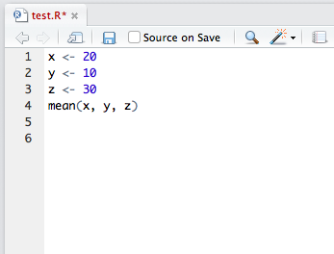

y <- 10

z <- 30

mean(x, y, z)

**Click on File > Save As... to save the script. Name it “test.R”**

When you try to save it, you will see it will automatically save in the directory you assigned.

**4. Running a Script**

**Highlight the Script and Click Run:**

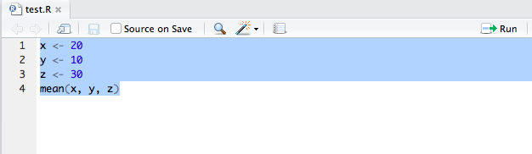

This runs each line of code, in the order listed. You can run one or more lines.

**5. Doing basic calculations on R (Arithmetic/ Built-in functions)**

The order of arithmetic operations is (left [done first] to right [done last]) : ^ / * - +

^ is used for raised to the power of, followed by division, multiplication, subtraction and addition.

**Copy and Paste these built-in Functions into your R script, then run the code!**

pi

exp(3) ## provides the cube of e

log(1.4) ## provides the natural logarithm of the number 1.4

log10(1.4) ## provides the log to the base of 10

sqrt(16) ## provides the square root of 16

Result:

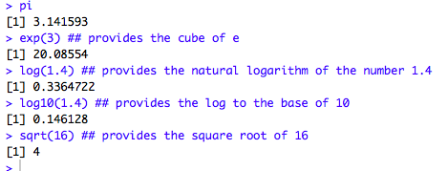

**6. Variables** (how to assign, reserved symbols, creating meaningful variables)

Variables are the symbols that store assigned values. We can store a computation under a new variable or change the existing value of an old variable. **Variable names in R are case sensitive** (upper or lower case). It is a good practice to assign meaningful variable names that helps to refer to easily for complex calculations.

To assign a value: variable_name <- value

**Example:**

currentYear <- 2016

birthYear <- 1990

age <- currentYear - birthYear

**Reserved Symbols**

In all programming languages certain symbols are reserved for specific purposes. The reserved symbols in R are -

c q t C D F I T

**Type q() in the Console and hit Enter to quit R (but don’t actually quit the program)**

**7. Exercise: You have already assigned values to variables x, y and z in your R script. Try assigning new variables and doing calculations on them.**

i <- 10

j <- 20

i*j - (i + j)

**Now try re-assigning different values and trying out some basic arithmetic calculations and built-ins using variables.**

Here are some things you can try out:

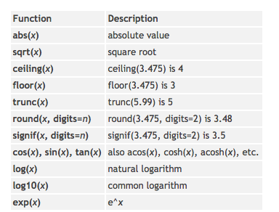

**8. Functions**

A function is a sub-program that performs a specific task. The built-in math operations we have seen such as mean(), sqrt() and cos() are functions. Functions help to avoid repetition and easy execution in future.

**Run the following code to understand how functions work. Create a function named “fun1.” Copy and paste it into your script, then run it!**

fun1 <- function(x){x*x -1}

fun1(3)

Result:

> fun1(3)

[1] 8

This function named “fun1” is supposed to return square of any integer minus 1.

**Now write a function that returns an integer multiplied by 10. Test it out!**

**9. Vectors**

Vectors have different meanings in different contexts. In math and physics, a vector is an element with both value and direction. But in R, vector is a sequence of data elements of the same basic type. It can be defined by concatenating the members in a set c().

Example: vect1 <- c(7, 1, 5, 3).

Once we have a vector of numbers we can apply certain built-in functions to them to get useful summaries. For example:

sum(x) ## sums the values in the vector

length(x) ## produces the number of values in the vector, ie its length

mean(x) ## the average (mean)

var(x) ## the sample variance of the values in the vector (has n-1 in denominator)

sd(x) ## the sample standard deviation of the values in the vector (square root of the

sample variance)

max(x) ## the largest value in the vector

min(x) ## the smallest number in the vector

median(x) ## the sample median

y < - sort(x) ## the values arranged in ascending order

**Exercise: Run the function you created, “fun1” on your vector, “vect1”**

vect1 <- c(7, 1, 5, 3)

fun1(vect1)

Your result should be a list of numbers that have been squared minus 1: (48, 0, 24, 8)

**11. Data Frame**

A data frame can be created by defining different variables for each column as vectors and then joining them together.

**Create three vectors listing different fruits with their names, colors and size:**

name <- c("apple", "banana", "peach", "watermelon", "grape")

color <- c("red", "yellow", "peach", "green", "red")

size_cm <- c(10, 15, 8, 40, 2)

**Add these three columns together to create the data frame names fruits.data**

fruits.data <- data.frame(name, color, size_cm)

**To see the values of the data frame, type fruits.data in the Console.**

fruits.data

name color size_cm

1 apple red 10

2 banana yellow 15

3 peach peach 8

4 watermelon green 40

5 grape red 2

**Add new variable to the data frame**

fruits.data["quantity"] <- c(2, 6, 5, 1, 30)

**Select a subset of fruits.data**

my.fruits <- subset(fruits.data, quantity < 5, select = c(name, quantity))

**Extra time activities**

**Working with variables**

* Select a variable by adding $ sign after the data frame’s name.

Ex: fruits.data$quantity

* Exclude variables v1, v2, v3

myvars <- names(mydata) %in% c("v1", "v2", "v3")

newdata <- mydata[!myvars]

* Exclude 3rd and 5th variable

newdata <- mydata[c(-3, -5)]

* To delete a variable you can set it to NULL. Example: newdata$X <- NULL.
* To delete multiple variables - newdata[1:2] <- list(NULL)

**Activity 2**

**Installing and Using Packages**

For this exercise we will use Hmisc, dplyr and ggplot2 packages. At first we will install the packages to our library and load them using the “library” function. There are two ways of installing packages - 1. Using the ‘Packages’ tab on menu bar, and 2. By typing install.packages(“package_name”) in console.

**Install Hmisc package:**

**Click on the Packages tab in the lower right window:**

Screen Shot 2017-01-09 at 12.10.48 PM.png

**Click Install**

**Type in Hmisc in the blank window under Packages. Click Install.**

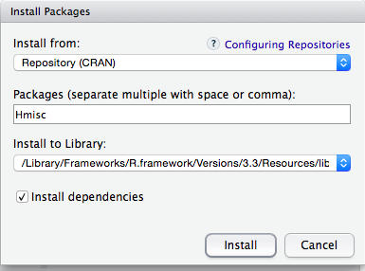

**Run the following code to load the package:**

library(Hmisc)

**Install dplyr and ggplot2 package following the same steps to install and load as the previous package.**

** or, the alternative way is to type & run this code:

install.packages(“plyr”)

library(plyr)

install.packages("dplyr")

library(dplyr)

install.packages(“ggplot2”)

library(ggplot2)

**Sample data sets in R -**

* The R Datasets Package - contains the list of all datasets available in R by default and details of the content <https://stat.ethz.ch/R-manual/R-devel/library/datasets/html/00Index.html>
* List of all datasets in R that can also be downloaded in CSV/Doc format - <https://vincentarelbundock.github.io/Rdatasets/datasets.html>

**For these exercises we will use sample datasets airquality and mtcars provided by R.**

**Loading data into R:**

Few things to keep in mind:

* Avoid names, values, fields with blank spaces, otherwise each word will be interpreted as a separate variable, resulting into errors in calculating the number of elements per line in the dataset.
* Shorter names are preferred over long names.
* Try to avoid using names that contain symbols such as ?, $,%, ^, &, *, (, ),-,#, ?,**,**,<,>, /, |, \, [ ,] ,{, and }
* Delete any comments in your file to avoid extra column or NA
* Make sure to indicate any missing value with NA.
* If the top row in your dataset has variable names then header = TRUE (default), otherwise set as FALSE.
  + If header = FALSE, R will set column names as V1, V2 … To define own column names specify them under col.names. Example: col.names = c("X", "Y", "Z", "A","B")

To load data:

* For text file, data_frame_name <- read.table(“path”)
* For CSV file, data_frame_name <- read.csv(“path”)

**\* You don’t have to type the full directory path if you have set your working directory.**

For further information refer to [This R Data Import Tutorial Is Everything You Need](https://www.datacamp.com/community/tutorials/r-data-import-tutorial#gs.KT=8444) from the DataCamp.

**Example of how to load in a dataset** -- first make sure you have put the file from (go.ncsu.edu/rworkshop/Datasets) into your working directory:

aq <- read.csv(“airquality.csv”)

**Remove the extra column X added**

aq$X <- NULL

**Try these examples with the airquality dataset (it’s already loaded into RStudio as a sample data set)**

# Returns first 10 rows of the data frame

head(aq, n = 10)

# Returns an overall summary of the data frame for each columns

summary(aq)

# Returns the mean for that specific column

mean(aq$Temp)

# Applies "mean" function over all the columns

sapply(aq, mean, na.rm = TRUE)

# Returns statistical observations of the data frame (Hmisc package function)

describe(aq)

# Create a subset where temperature is greater than 80 degrees

warmDays <- subset(aq, Temp > 80, select = c(Day, Month, Temp))

# Reorders columns (function from Dplyr package)

arrange(warmDays, Temp)

# Count the days in a month for each temperature

count(warmDays, c("Temp", "Month"))

# Find the average temperature for each month

aggregate(Temp ~ Month, data = aq, mean)

**Creating Plots (Basic plotting, ggplot2)**

# Splits the screen into two

par(mfrow = c(1, 2))

**This uses the mtcars dataset. To see the data, type:**

mtcars

**Result:**

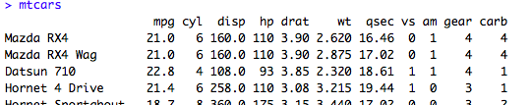

**...**

**You can load the dataset into R or directly work on the one provided by R**

Plot by default refers to Scatter plot. The basic function is plot(x, y), where x and y are numeric vectors.

**Example: Find out the relationship between car weight and mile per gallon (mpg) use from mtcars dataset.**

plot(mtcars$wt, mtcars$mpg, main="Scatterplot Example", xlab="Car Weight ", ylab="Miles Per Gallon ", pch=19)

# Add fit lines

abline(lm(mtcars$mpg~mtcars$wt), col="red") # regression line (y~x)

lines(lowess(mtcars$mpg~mtcars$wt), col="green") # lowess line (x, y)

#The same graph can be created using the ggplot function too.

qplot(mtcars$wt, mtcars$mpg)

# If the two vectors are already in the same data frame, you can use the following syntax:

qplot(wt, mpg, data=mtcars)

# This is equivalent to:

ggplot(mtcars, aes(x=wt, y=mpg)) + geom_point()

The path type is “point” by default in Scatter plot. To change it to line add - type = “l”, or mix of point and line - type = “o”

Example:

plot(pressure$temperature, pressure$pressure, type="l")

**Histogram - view the distribution of one dimensional data**

hist(mtcars$mpg)

# Specify approximate number of bins with breaks

hist(mtcars$mpg, breaks = 10)

# Use ggplot2

qplot(mtcars$mpg)

qplot(mpg, data = mtcars, binwidth = 4)

**Boxplot of MPG by Car Cylinders**

boxplot(mpg~cyl,data=mtcars, main="Car Milage Data",

xlab="Number of Cylinders", ylab="Miles Per Gallon")

**Generate a bar plot**

barplot(mtcars$wt)

# Generate a table of counts

barplot(table(mtcars$cyl))

# Using ggplot2

qplot(mtcars$cyl)

# Treat cyl as discrete

qplot(factor(mtcars$cyl))

_______________________________________________________________________

**Want to Go Deeper with R?**

To learn more about visualization with R refer to: Chang, W. (2012). R graphics cookbook. " O'Reilly Media, Inc."